**Report on general government budget**

**MAY 2020**

General government budget recorded a **deficit of RON 38.84 billion (3.59% of GDP)** in the first five months of 2020, almost half of this amount corresponding to uncollected taxes (amounts left to private companies to support their liquidity) and exceptional expenses to combat the pandemic (Annexes 1 and 2).

Compared to the similar period of last year, the larger deficit is mainly explained by the unfavourable total revenues’ dynamics in March – May as a consequence of payment deferral during the state of emergency (RON 11.7 billion)[1], higher VAT reimbursement (RON +2.26 billion) to support private companies’ liquidity, and discounts offered to CIT taxpayers and for taxes on micro-enterprises’ revenues (RON 0.25 billion). Furthermore, on the expenditure side, beside the increase in expenditure as a result of applying current legislation, investment increased by RON 3.43 billion, while exceptional payments related to Covid-19 pandemic totalled RON ~3.83 billion.

1. **general government revenue**

Total revenue amounted to RON 119.59 billion in the first five months of the year, down by 3.4% compared to the corresponding period of last year, mainly due to fiscal facilities adopted to support the economic activity in the context of the Coronavirus pandemic (in particular payment deferral and discounts offered to CIT taxpayers). Also, the contraction of revenues in May (-12% yoy) is explained by the unfavourable evolution of the economic activity in April since the state of emergency restrictions were applied all month long.

***Personal income tax*** receipts totalled RON 9.57 billion in the first five months of the year, advancing by 4% (yoy). This evolution was backed by higher revenues from pensions (+40.8% yoy) and dividends (+23.4% yoy).

While the wage bill expanded by 7.3% over Dec’19 – Apr’20, the labour income tax receipts increased only marginally in the first five months of the year due to tax deferral (+0.7% yoy).

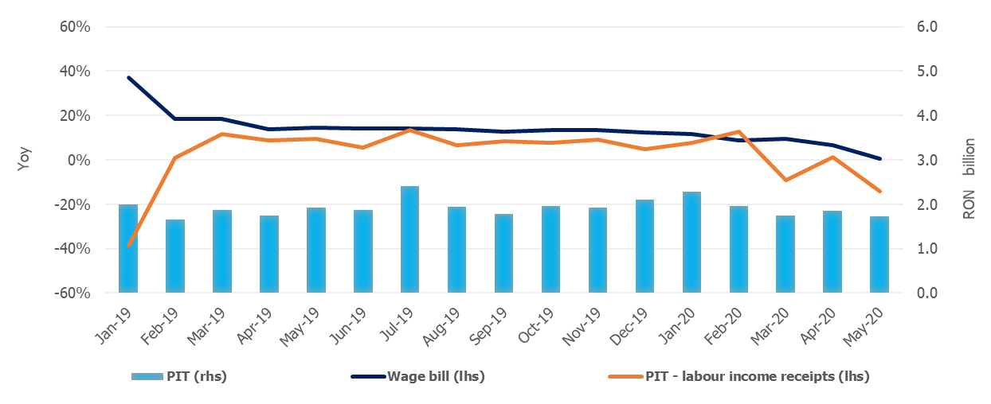

Source: MoPF, NIS, own calculations

**Fig.1 Personal Income Tax Revenue**

***Social contribution*** revenuetotalledRON 44.65 billion in the first five months, down by 2.1% compared to the corresponding period of last year. Social contributions revenues were adversely affected by: (i) the change in the calculation basis of social security contribution (CAS) and health insurance contribution (CASS) due by part-time employees, (ii) the extension from March 15th to June 30th of the submission deadline of the Single Fiscal form for individuals with independent activities, (iii) exemption from work insurance contribution (CAM) payment during the state of emergency[2], and (iv) payment deferral.

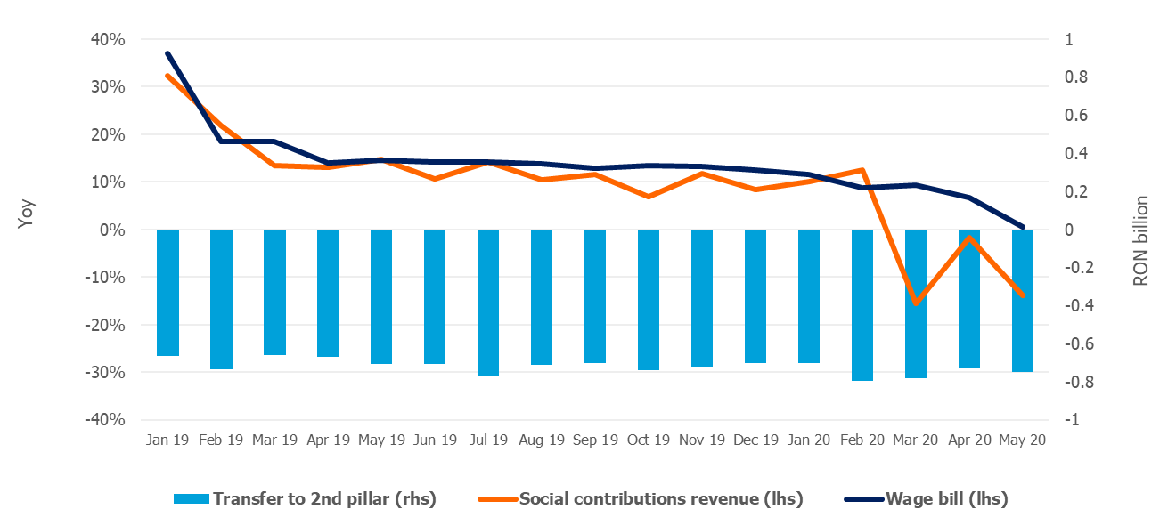

Source: MoPF, NIS, own calculations

**Fig.2 Social contribution revenue**

***Corporate income tax*** revenue amounted to RON 6.90 billion in the first five months of the year, down by 12.5% compared to the similar period of last year. The negative dynamics is mainly explained by payment deferral (GEO no. 29/2020), as well as discounts offered to CIT taxpayers who paid the tax owed: 5% for large taxpayers and 10% for small and medium taxpayers (GEO no. 33/2020, total impact of RON 0.22 billion).

***Other taxes on income, profit and capital gains from juridical persons*** amounted to RON 1.49 billion in the first five months of the year, down by 3.4% (yoy), mainly reflecting payment deferral for micro-enterprises revenues taxpayers[3] (GEO no. 29/2020), as well as 10% discounts offered to those who paid the tax owed (GEO no. 33/2020, total impact of RON 0.03 billion)

***VAT*** receipts amounted to RON 20.11 billion in the first five months of 2020, down by 18.9% compared to the similar period of last year.

Over the first five months, the VAT revenues dynamics was negatively influenced by: (i) higher VAT reimbursement by 28.4% (yoy) in order to provide additional liquidity to private companies during the economic downturn, (ii) tax deferral, (iii) unfavourable evolution of economic activity since March, in particular services, manufacturing and retail.

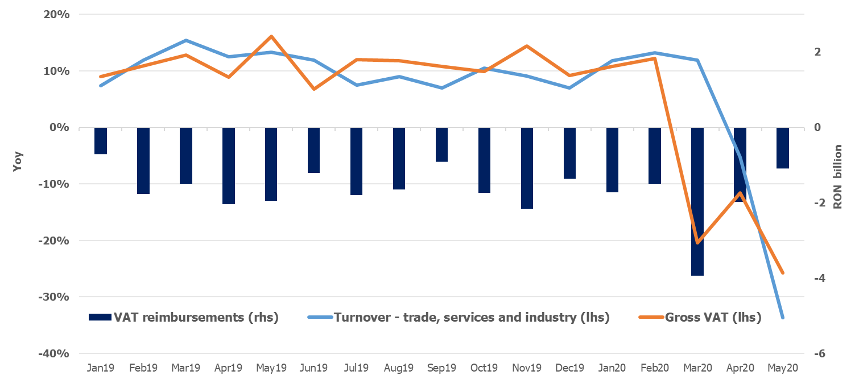

Source: MoPF, NIS, own calculations

**Fig.3 VAT revenue**

***Excise duties*** receipts totalled RON 11.67 billion in the first five months of 2020, decreasing marginally compared to the similar period of last year (-0.1%, yoy).

Over the first five months, excise revenue from energy products decreased by 15.4% (yoy) mainly due to fuel consumption decline since March, when the state of emergency was established. On the other hand, excise revenue from tobacco products grew by 18.6% (yoy), backed by a 4.2% hike in the excise level for cigarettes.

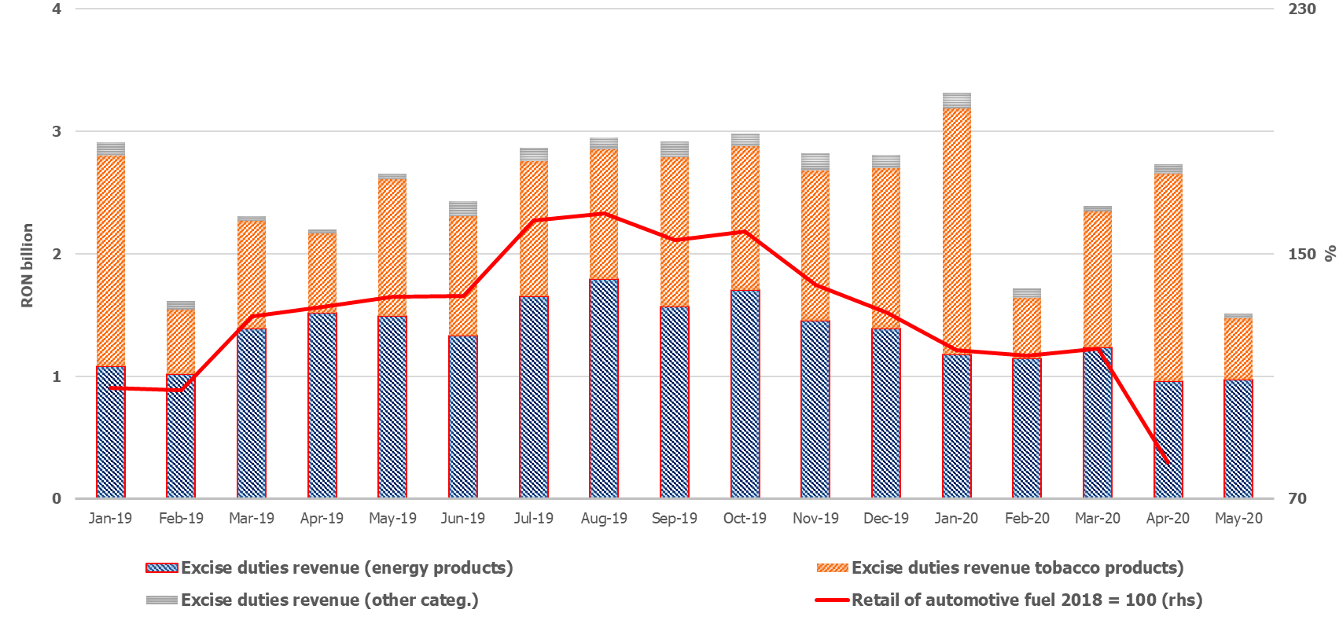

Source: MoPF, NIS, own calculations

**Fig.4 Excise duties revenue**

Revenue from ***taxes on use of goods*** totalled RON 2.16 billion in the first five months of the year, advancing by 137.2% (yoy). The positive dynamics is mainly explained by the revenue collected from broadcast licenses renewal (GD no. 226/2020). Conversely, revenues from gambling taxes declined by 56.5% (yoy) due to payment deferral (GEO no. 29/2020), suspension of payment obligations for traditional gambling licenses, and exemption from payment of gambling authorizations during the state of emergency (GEO no. 48/2020).

***Non-tax revenues*** amounted to RON 9.04 billion in the first five months of 2020, up by 3.1% compared to the similar period of last year.

***EU refunds and donations*** totalled RON 7.58 billion in the first five months, advancing by 24.8% (yoy).

1. **GENERAL GOVERNMENT EXPENDITURE**

General government expenditure totalled RON 158.43 billion in the first five months of the year, advancing by 14.4% compared to the corresponding period of the previous year. As a percentage of GDP, total expenditure increased by 1.57 percentage points, from 13.07% in 2019 to 14.64% in 2020. This increase is also explained by the measures adopted to limit the spread of the virus, and on the other hand by discretionary measures adopted in order to mitigate the negative impact on the economic activity.

Moreover, RON 2.29 billion were paid in the first five months for technical unemployment benefits, RON 440.1 million for other categories of professionals and for those with an individual employment agreement that were forced to stop their activity in the context of the state of emergency, and RON 9.0 million for allowances to parents in order to supervise their children when educational institutions were temporary closed.

***Compensation of employees***  totalled RON 43.99 billion, up by 5.2% compared to the same period of last year, reflecting public wage hikes and introduction of meal allowance to all public employees as of January 1st, 2019 (Law no. 153/2017), but also by another round of public wages hikes as of January 1st, 2020. As a percentage of GDP, compensation of employees represented 4.1%, increasing only marginally (+0.12 percentage points) compared to the first five months of last year. In addition, RON 74.2 million were paid in May to award bonuses to the medical staff treating Covid-19 patients.

***Goods and services expenditure*** amounted to RON 21.10 billion, advancing by 16.2% compared to the similar period of last year (+ 15.6% yoy for local budgets level and + 15,7% for some public institutions entirely or partially self-financed), mainly due to additional payments for drugs, sanitary materials and other products needed to test and to treat the people infected with Coronavirus.

Furthermore, compared to the similar period of last year, a 13.6% increase was recorded at the level of the Unique National Fund of Health Insurances due to higher payments for drugs and outpatient medical services reimbursements.

***Social assistance expenditure*** reached RON 56.83 billion, up by 21.9% compared to the similar period of last year. This dynamics is mainly explained by the increase of the pension point by 15% as of September 1st, 2019 (from RON 1,100 to RON 1,265); the increase of the social allowance for pensioners by 10%; of child allowance as of May 1st, 2019, as well as indexing child allowance with 2019 inflation rate as of January 1st, 2020.

At the same time, since April, additional payments have been made to offset the negative impact of the Coronavirus outbreak: temporary unemployment benefits (RON 2.29 billion) and unemployment benefits for other categories of professionals and for those with an individual employment agreement that were forced to stop their activity due to the pandemic (RON 440.1 million). Furthermore, the sick leave reimbursements continue to be repaid at an accelerated pace (RON 637.6 million in May), in order to reduce the stock of outstanding payments.

***Subsidies*** reached RON 3.55 billion, the largest part being allocated to the agricultural sector, i.e. payments for the transitional national aid in the vegetal and zootechnical sector.

***Other expenditure*** amounted to RON 2.51 billion, representing mainly amounts related to payment titles issued by the National Authority for Properties Restitution, scholarships for students and payments related to court decisions, as well as allowances paid to parents in order to supervise their children when educational institutions were temporary closed (RON 9.0 million).

***Expenditure for projects financed from non-reimbursable external funds*** (including EU subsidies for agriculture) reached RON 8.84 billion, up by 27.9% compared to the similar period of last year.

***Investment***, which includes capital expenditure and spending related to development programs financed from domestic and external sources, amounted to RON 13.0 billion, registering the peak of the last 10 years (for the first five months period). Compared to the similar period of last year, investment grew by 35.8% (reflecting increases at both central and local level, financed from both domestic and non-reimbursable external funds).

Furthermore, RON 235.0 million were paid from the budget of the Ministry of Internal Affair for the purchase of emergency medical products, including thermal scanners, in order to limit the spread of the Coronavirus.



Source: MoPF

**Fig. 5 Public investment structure**









1. Fiscal facility granted through GEO no. 29/2020 regarding certain economic and fiscal measures to support private companies.
2. GEO no. 30/2020, amended by GEO no. 32/2020
3. Taxes on micro-enterprises revenues represent ~99% of the category *other taxes on income, profit and capital gains from juridical persons.* 